IPOC1K TX&RX CASCADE CONFIGURATION INSTRUCTION
- Overview
IPOC1K TX/RX has been defaulted to a unified Network name” HomePlugAV”, When using multiple pairs of IPOC1K TX / RX to cascade with the switch, you will have loop problems if you don’t change the network name. It is suggested to set up as a pair or group. Different network name isolates the communication between those pairs/groups.
To change the network name, you need to install two soft wares in your pc, one cat5/6 RJ45 patch lead, direct connect the transmitter/receiver to your PC, instructions are as follows.

- Modify the device network name
- Install the software in the package on the PC , Double click ,then double click The Figure 1 will appear
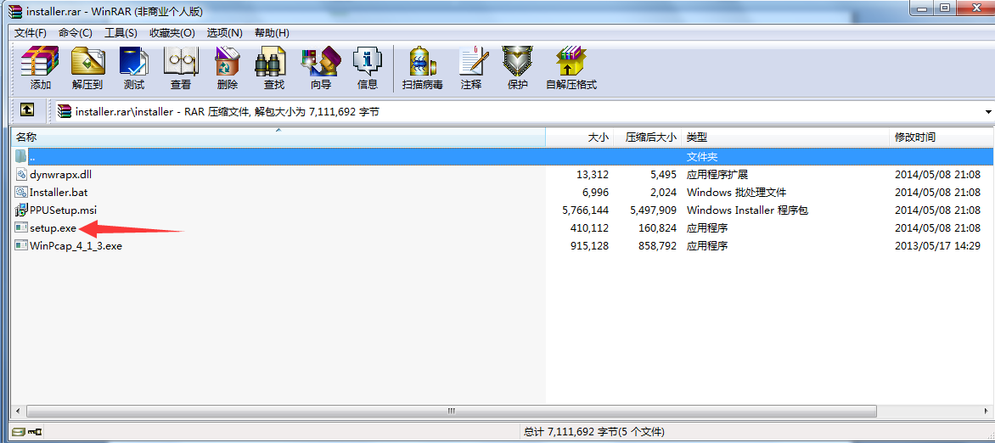Figure 1
Double click the “setup.exe”, the Figure 2 will appear
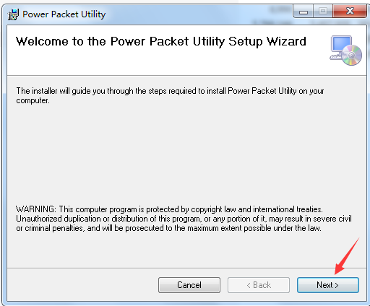
Figure 2
Choose the “I Agree” column; then click “next”, the Figure 3 will appear
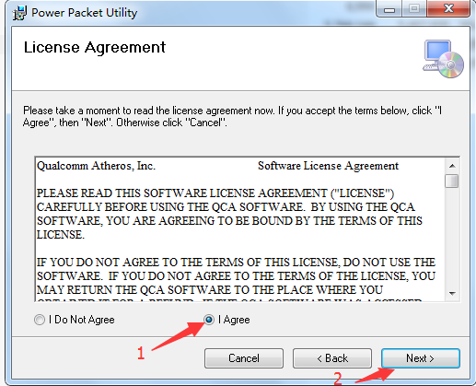
Figure 3
Click “next”
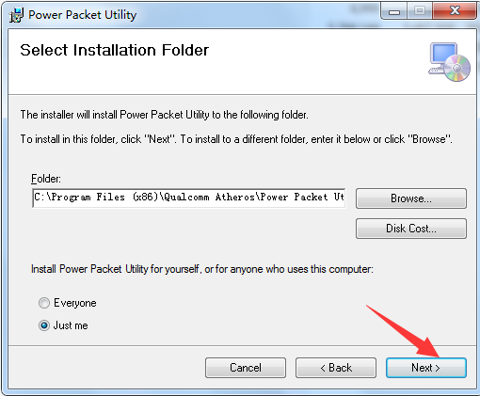
Figure 4
Click “next”
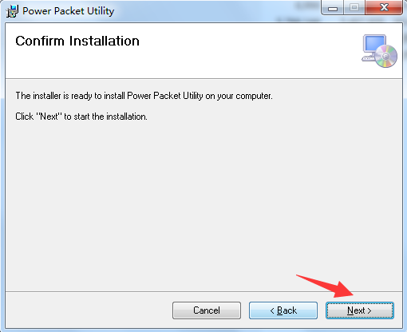
Figure 5
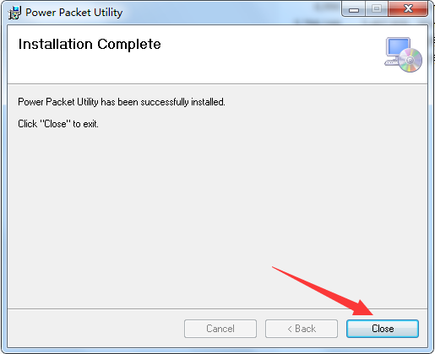
Figure 6
A few seconds later, the software installation complete, After correct installation, the icon will display on the computer desktop, as follows
- Install WinPcap4.1.3, which is in the zip file as well, double click and follow the prompts.

- Connect the IPOC1KTX/RX RJ45 port to the PC network port and power on the device,
- Double-click the icon to run the software, the interface is shown in Figure 7
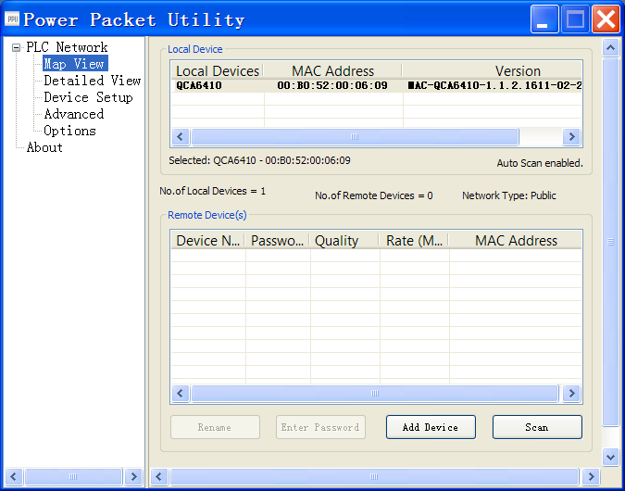
Figure 7
- Click the “Device Setup” column, as shown in Figure 8, in the “Private Network Name” column, you can see the default “Private Network Name” is HomePlugAV.
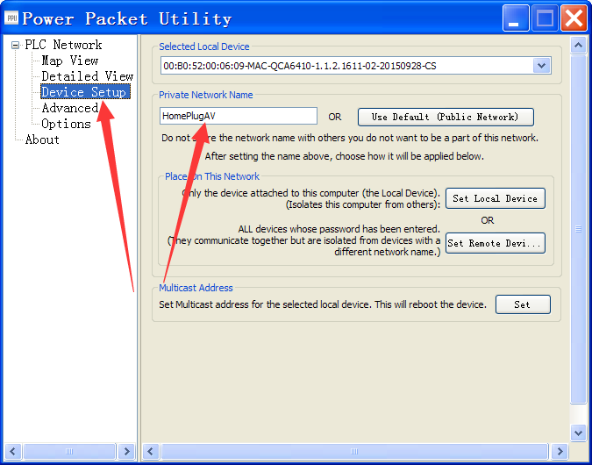
Figure 8
- Please configure the “Private Network Name” column to any name you like, such as “Group1”, as shown in Figure 9
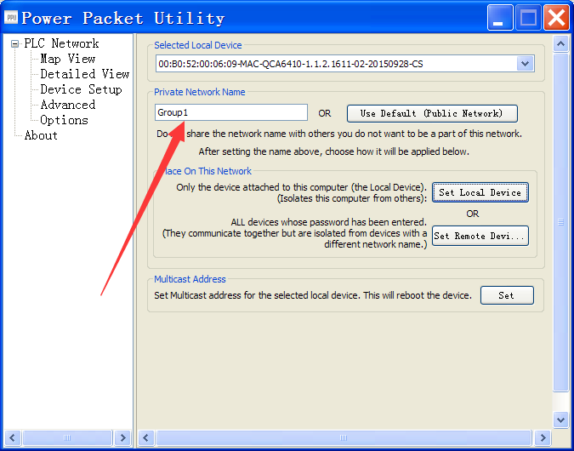
Figure 9
- Click the “Set Local Device” column , as shown in Figure 10
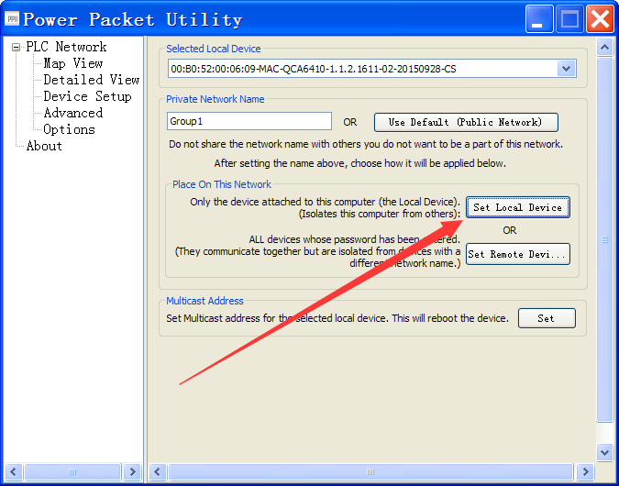
Figure10
- After a few seconds, the following dialog box-Figure 11 will pop up. Click “确定(ok)” button to indicate that the network name has been changed.
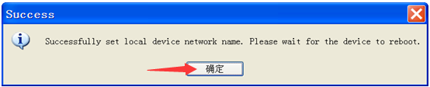
Figure 11
- Then change each of IPOC TX or RX in order, the same group of IPOC1K TX and RX Network name must be the same, different groups of IPOC1K TX / RX Network name must to be set to different values, such as Group1 Group2 Group3.

